


AMERICAN CAR CRAFT INSTRUCTION

C3 Corvette Doorsills Part# 011002
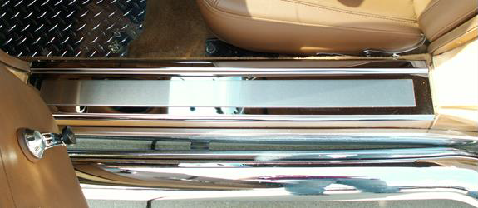
PARTS INCLUDED:
2- Doorsills
2-Adhesive Promoter Packs

Your new doorsills come to you with a protective liner; do not remove liner until installation is complete.
- Remove the factory extruded aluminum sill and save it for its restoration value. If necessary trim the carpet back to the rear edge of the exposed sill to allow the new sill to sit flat on the fiberglass. In most cases with the original carpet this will often be a minor trim and can be performed with a razor blade to achieve a nice straight and smooth cut.

- Scrub the exposed fiberglass sill with alcohol to remove any and all dirt and grime then swipe the area with the adhesive promoter provided. This part of the installation is very important because the design of this sill is to bond the factory sill area so the surface must be thoroughly cleaned and prepped.

- Before you permanently attach the new sill set it in place to get acquainted with the sill’s position and just how you will insert the part. Because the attachment tape is very aggressive you will need to be able to set the new sill in place in one accurate motion so practice setting it in.

- Now that you have prepared the surface and have a good idea of just how the new sill will set in place simply remove the red release liner from the back of the sills and then filmy press them in place. Push down on the attachment tape areas with a soft cloth then remove the protective liner to finish the installation.

Thank you and enjoy your purchase!
If any questions occur during installation please contact AMERICAN CAR CRAFT
18924 SAKERA ROAD-HUDSON FLORIDA 34667
Phone # 727-861-1500 Fax # 727-861-1520
www.americancarcraft.com

