AMERICAN CAR CRAFT
18924 SAKERA ROAD-HUDSON FLORIDA 34667
Phone # 727-861-1500 Fax # 727-861-1520
www.americancarcraft.com

C3 Corvette Doorsills Part# C310 patent pending Installation Instructions

Items Included:
2- Doorsills
2-Adhesive Promoter Packs
Your new doorsills come to you with a protective liner; do not remove liner until installation is complete.

This new high quality door sill is a unique and authentic double layered stainless steel accessory. For years the real thing has been copied in one form or another providing you as a customer with a nice looking imitation of what we have now made for you for real. This is a top of the line sill and is very easy to install.

- Remove the factory extruded aluminum sill and save it for its restoration value. If necessary trim the carpet back to the rear edge of the exposed sill to allow the new sill to sit flat on the fiberglass. In most cases with the original carpet this will often be a minor trim and can be performed with a razor blade to achieve a nice straight and smooth cut.

- Scrub the exposed fiberglass sill with alcohol to remove any and all dirt and grime then swipe the area with the adhesive promoter provided. This part of the installation is very important because the design of this sill is to bond the factory sill area so the surface must be thoroughly cleaned and prepped.

- Before you permanently attach the new sill set it in place to get acquainted with the sill’s position and just how you will insert the part. Because the attachment tape is very aggressive you will need to be able to set the new sill in place in one accurate motion so practice setting it in.
- Now that you have prepared the surface and have a good idea of just how the new sill will set in place simply remove the red release liner from the back of the sills and then filmy press them in place. Push down on the attachment tape areas with a soft cloth then remove the protective liner to finish the installation.

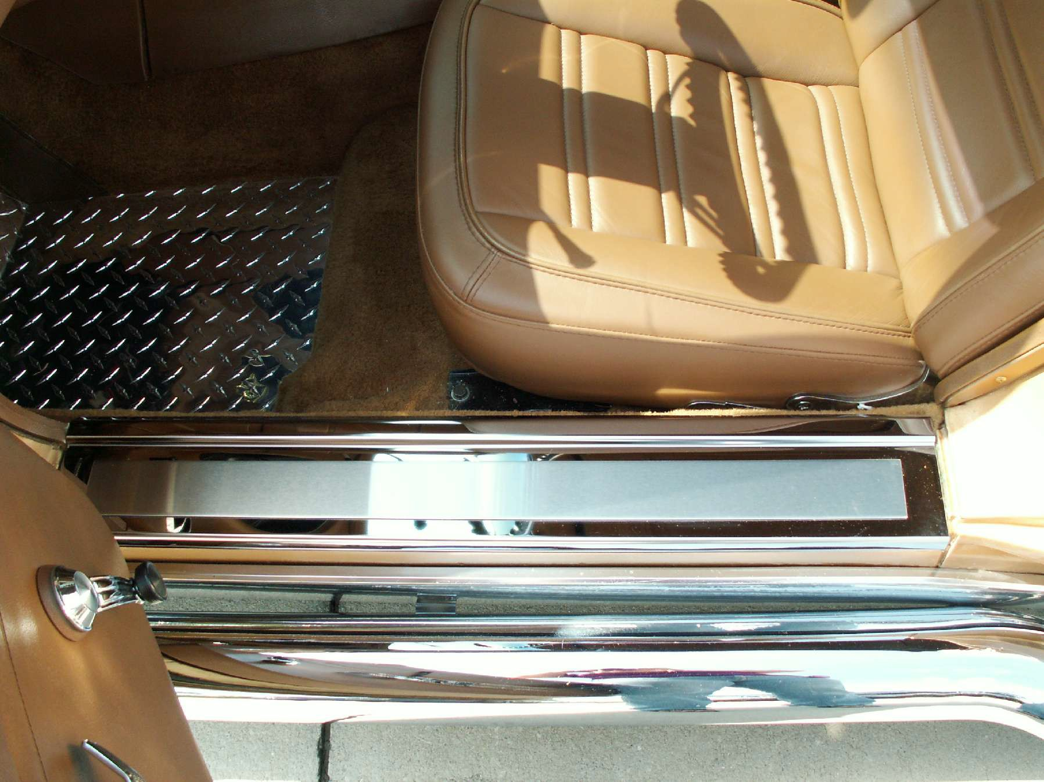
If any questions occur during installation, please contact American Car Craft at 727 861-1500
Thank you and enjoy your new purchase.

Note: Care must be taken when cleaning your new sills. It is a good idea to lightly dust your sills with a clean soft cloth (or a clean California style duster) first in order to prevent any particles from scratching them. (NOTE: Once this metal is scratched it can not be repaired so please use extra care when cleaning these sills.) Then spray and wipe (using a new clean soft cloth or lint free paper towels) with a good quality streak free glass cleaner.

